National Novena to Four Saints of Color
for Justice, Charity and Peace

“If my people who are called by my name humble themselves, and pray and seek my face, and turn from their wicked ways,
then I will hear from heaven, and will forgive their sin and heal their land” - 2 Chron 7:14

Appeal to the Saints in Heaven

Dear Venerable Fr. Augustus Tolton, Venerable Pierre Toussaint, Saint Josephine Bakhita and Saint Martin de Porres, with humble and contrite hearts we come to implore your heavenly assistance in healing the wounds that centuries of racism have inflicted on our national community. In the love of Jesus Christ, who ‘took the form of a slave’ and was persecuted unto death, you found how radically God has identified himself with the plight of all who suffer. Knowing yourselves to be so deeply loved by God, you were able to forgive those who mistreated you, blind as they were to their own and their neighbor's dignity.
We implore you to help us build a society founded on justice and charity. Since “the pure of heart shall see God,” may the fire of the Holy Spirit and the grace of humble repentance purify the heart of every American, that we may recognize the image of God in every one of our brothers and sisters. (Mt 5:8) Please pray with us as we ask the Lord Jesus to give us hearts that are truly “rooted and grounded in love” for God and neighbor (Eph 3:17).

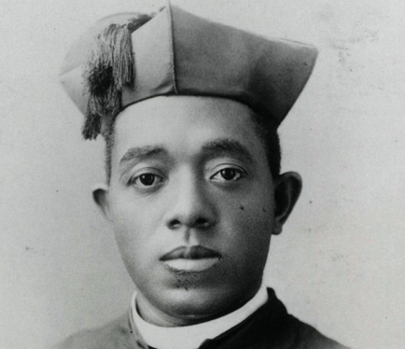
Ven. Augustine Tolton was the first Roman Catholic priest in the United States publicly known to be African American when he was ordained in 1886, even though he was discouraged from the path at every turn. He was a great pastor to both blacks and whites and an eloquent speaker and singer.

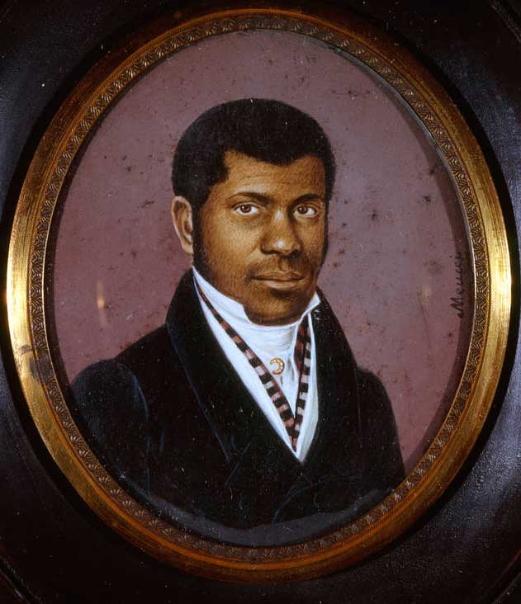
Ven. Pierre Toussaint was born a slave in Haiti, was brought to the United States, and freed in 1807. He then married and he and his wife became famous for their charitable donations and opening their home to orphans and victims of yellow fever.

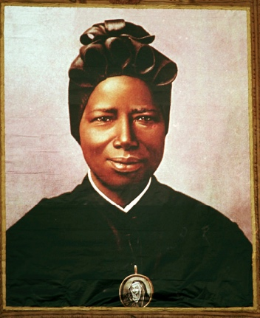
St. Josephine Bakhita was born in Sudan, kidnapped and sold into slavery at age 7, taken to Italy. When her owners wanted to take her back to Italy, she took them to court and won her freedom, as slavery was illegal in Italy. She then entered the Canossian Sisters, and became one of their most beloved members.

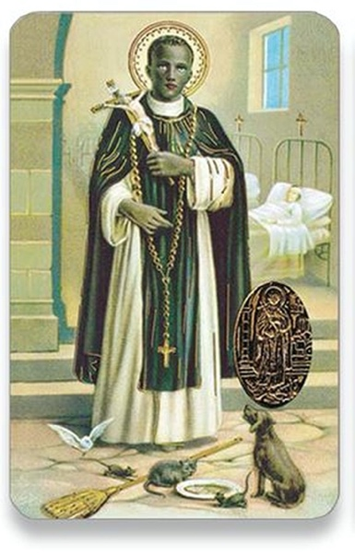
St. Martin de Porres was the illegitimate son of a Spanish nobleman and a freed slave of African-Native American origin. Martin entered the Dominicans and was known as a miracle healer and a staunch friend of the poor and downtrodden.

Litany of the Sacred Heart

Lord, have mercy. R/ Lord, have mercy.
Christ, have mercy. R/ Christ, have mercy.
Lord, have mercy. R/ Lord, have mercy.
Christ, hear us. R/ Christ, graciously hear us.

(R/ “have mercy on us” after each line.)

God the Father of Heaven…
God the Son, Redeemer of the world…
God the Holy Spirit…
Holy Trinity, one God…
Heart of Jesus, Son of the Eternal Father…
Heart of Jesus, formed by the Holy Spirit in
the Virgin Mother's womb…
Heart of Jesus, substantially united to the
Word of God…
Heart of Jesus, of infinite majesty…
Heart of Jesus, holy temple of God…
Heart of Jesus, tabernacle of the Most High…
Heart of Jesus, house of God and gate of heaven…
Heart of Jesus, glowing furnace of charity…
Heart of Jesus, vessel of justice and love…
Heart of Jesus, full of goodness and love…
Heart of Jesus, abyss of all virtues…
Heart of Jesus, most worthy of all praise…
Heart of Jesus, King and center of all hearts…
Heart of Jesus, in whom are all the treasures
of wisdom and knowledge…
Heart of Jesus, in whom dwells all the fullness of the Godhead…
Heart of Jesus, in whom the Father was well pleased…
Heart of Jesus, of whose fullness we have all received…
Heart of Jesus, desire of the everlasting hills…
Heart of Jesus, patient and rich in mercy…
Heart of Jesus, rich to all who call upon You…
Heart of Jesus, fount of life and holiness…
Heart of Jesus, propitiation for our offenses…
Heart of Jesus, overwhelmed with reproaches…
Heart of Jesus, bruised for our iniquities…
Heart of Jesus, obedient even unto death…
Heart of Jesus, pierced with a lance…
Heart of Jesus, source of all consolation…
Heart of Jesus, our life and resurrection…
Heart of Jesus, our peace and reconciliation…
Heart of Jesus, victim for our sins…
Heart of Jesus, salvation of those who hope in You…
Heart of Jesus, hope of those who die in You…
Heart of Jesus, delight of all saints…

Lamb of God, who takes away the sins of the world,
R/ Spare us, O Lord.
Lamb of God, who takes away the sins of the world,
R/ Graciously hear us, O Lord.
Lamb of God, who takes away the sins of the world,
R/ Have mercy on us.
Jesus, meek and humble of Heart,
R/ Make our hearts like unto Thine.

Closing Prayer

Let us pray (pause): Merciful Savior, through the intercession of Vens. Augustus & Pierre, Sts. Josephine & Martin, forgive all our sins against your two great Commandments—to love God above all things and our neighbors as ourselves. Instill in us a deep reverence for the sacred dignity of all human life and the courage to fight for those who are deprived of their rights. By the reconciling power of your Precious Blood, heal the strife that separates us from one another and from you. Thus, may we finally become in truth, “one nation under God, indivisible, with liberty and justice for all.” Through Christ Our Lord.
R/ Amen.

It is recommended to pray five decades of the Holy Rosary and perform at least one work of mercy each day.

